**Program from softcopy: c-4**

**Problems :**

1. **Use of getchar function**
2. **Program to test the char type**
3. **Reading and writing of alphabets in reverse case**
4. **Formatted output of integers**

**No:1 || Program:A program about using getchar function**

**Source code:**

main()

{

char answer;

printf("Would you like to know my name???\n\n");

printf("Type 'Y' for Yes and 'N' for No : ");

answer=getchar(); //reading a character

if(answer == 'y'|| answer == 'Y')

printf("\n\nMy name is Busy BEE\n");

else

printf("\n\nYou are good for nothing\n");

}

**Sample input :**

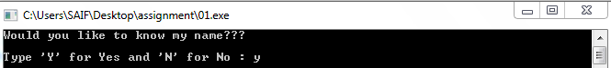

**Sample output:**

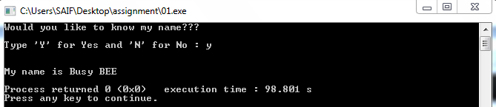

**No:2 || Program:A program about testing character type**

**Source code:**

**main()**

**{**

**char X;**

**printf("Press any Key :");**

**X=getchar();**

**if(isalpha(X)>0)**

**printf("\nThe character is a lattar.\n");**

**else**

**if(isdigit(X)>0)**

**printf("\nThe character is a digit.\n");**

**else**

**printf("\nThe character is not alphanumeric.\n");**

**}**

**Sample input**:



**Sample Output :**

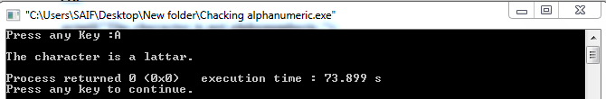

**No:3 || Program:A program Reading and writing of alphabets in reverse case**

**Source code:**

**main()**

**{**

**char alphabet;**

**printf("Enter an alphabet");**

**putchar('\n'); //move to next line**

**alphabet=getchar();**

**if(islower(alphabet))**

**putchar(toupper(alphabet));**

**else**

**putchar(tolower(alphabet));**

**}**

**Sample input:**



**Sample output:**

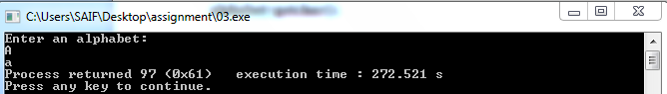

**No:4 || Program: A program Formatted output of integers**

**Source code:**

**main()**

**{**

**int m=12345;**

**long n=987654;**

**printf("%d\n",m);**

**printf("%10d\n",m);**

**printf("%010d\n",m);**

**printf("%-10d\n",m);**

**printf("%10ld\n",n);**

**printf("%10ld\n",-n);**

**}**

**Sample output:**

